# ISTIO Service Mesh

Introduction to Istio  
  
ICA – Istio certified Associate  
  
  
Istio similar service mesh tools are –---- LinkerD , cilium , traefik , harshicorp Consul , Aws App mesh , Nginx service mesh.  
  
Most used proxy in servicmesh as a sidecar container ids envoy.  
  
  
  
  
ENVOY  
  
🡪 Envoy proxy routes the traffic through the best path to deliver messages and acts like a load balancer if there are multiple services  
🡪 Envoy proxy also make sure the communication between services are secure. It encrypts the message and responds to the required services  
🡪it tracks traffic volume to each application , measures response time , Detects application issues  
  
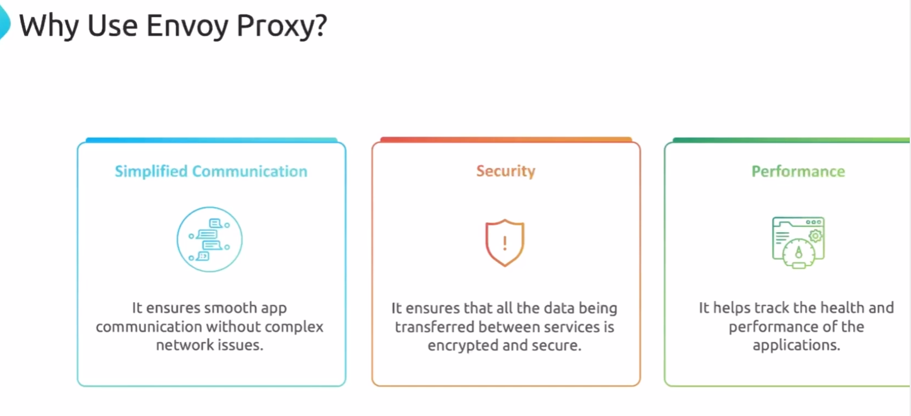  
  
Istio  
istio is a opensource service mesh for running microservices apps across any environment.  
  
  
Data plane  
  
🡪Data plane is responsible for managing and controlling the actual traffic between microservices  
🡪Data plane deploys sidecars proxies envoy in the microservices and it handles load balancing , encryption using MTLS and security authentication  
  
Control Plane  
  
🡪 control plane is responsible for managing and configuring the data plane. It handles network policies , certificate authority , authentication/authorization and dynamically updating the configuration for all the proxy side cars all of this will be handled by the istioD which is a pod runs inside the container   
  
istiod provide service discovery and configuration it translates high level routing rules.  
istiod acts as a certificate authority and generates certificates to allow secure MTLS communication between the workloads   
istiod also allows you to secure service to service and end user authentication with built-in identity  
  
  
  
  
Istio also offers sidecar less mesh called Ambient mesh.  
  
  
  
Installation  
[Releases · istio/istio](https://github.com/istio/istio/releases) – all versions  
[Releases · istio/istio](https://github.com/istio/istio/releases?page=9) - istio version page 9 – 1.18.2  
  
  
  
  
  
  
  
  
**Download Istio**

https://istio.io/latest/docs/setup/additional-setup/download-istio-release/

curl -L https://istio.io/downloadIstio | sh -  
or  
curl -L https://istio.io/downloadIstio | ISTIO_VERSION=1.18.2 TARGET_ARCH=x86_64 sh - ----->specific version

cd istio-1.26.1

export PATH=$PWD/bin:$PATH

**instead of cd and export commands**

sudo install -m 755 ./istio-1.18.2/bin/istioctl /usr/local/bin/istioctl  
-----------------------------------------------------------------------------------------------  
istioctl install --set profile=demo -y ---> latest version

kubectl get pods -n istio-system

**To enable istio in the specific namespace**

kubectl label namespace default istio-injection =enabled  
  
  
  
root@controlplane ~/istio-1.18.2 ➜ istioctl analyze -n default

Info [IST0102] (Namespace default) The namespace is not enabled for Istio injection. Run 'kubectl label namespace default istio-injection=enabled' to enable it, or 'kubectl label namespace default istio-injection=disabled' to explicitly mark it as not needing injection.

root@controlplane ~/istio-1.18.2 ➜ istioctl analyze -n default

---------------------------------------------------------------------------------

Manual side car injection

istioctl kube-inject -f pod.yaml | kubectl apply -f - -n db

----------------------------------------------------------------------------------

validation of yaml file

istioctl validate <filename>

-----------------------------------------------------------------------------------

verify install

istioctl verify install

---------------------------------------------------------------------------------  
  
  
Installing Istio Using Helm

$ helm repo add istio https://istio-release.storage.googleapis.com/charts

$ helm repo update

$ helm install istio-base istio/base --namespace istio-system --version 1.18.2 --create-namespace

$ helm install istiod istio/istiod --namespace istio-system --version 1.18.2 --wait

$ helm install istio-ingress istio/gateway --namespace istio-ingress --version 1.18.2 --create-namespace

$ helm ls -A

------------------------------------------------------------------------------------------------------------------

istio install using helm

which helm

helm repo list

helm repo add istio https://istio-release.storage.googleapis.com/charts

helm repo update

helm install istiod istio/istiod --namespace istio-system --version 1.18.2 --set profile=demo --set pilot.resources.requests.memory=128Mi --set pilot.resources.requests.cpu=250m

kubectl get pods -n istio-system

helm install istio-ingress istio/gateway --namespace istio-ingress --version 1.18.2 --create-namespace

kubectl get pods -n istio-ingress

--------------------------------------------------------------------------------------  
  
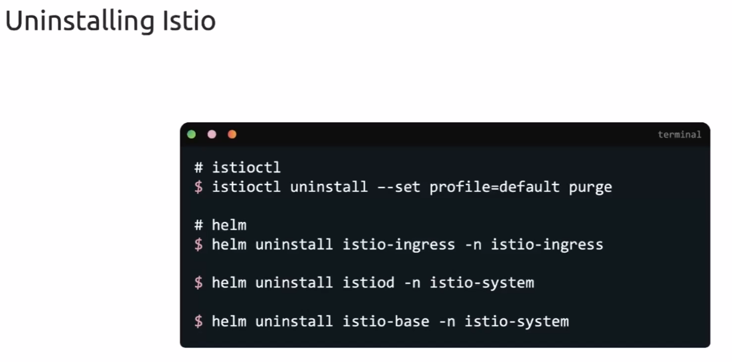  
  
  
--------------------------------------------------------------------------------------

**After installing istio doing change and applying yaml (Operator)( 1 question ICA)**

istioctl profile dump demo -o yaml > demo.yaml

istioctl install --set profile=demo --skip-confirmation

apiVersion: install.istio.io/v1alpha1

kind: IstioOperator

metadata:

name: demo

spec:

# your configuration here

kubectl apply -f demo.yaml  
  
  
  
  
  
  
  
  
  
Traffic Management(40 % of question in ICA)  
  
Default Sidecar Behavior  
  
  
Custom sidecar behavior  
by default sidecar will communicate in with all namespaces we can restrict it to specific namespaces by below  
./* 🡪 itself namespace   
app/* 🡪 app namespace - /* means all the workloads in that namespace  
istio-system/* 🡪 istio-system namespace - - /* means all the workloads in that namespace